Georgia Public Library  1697 Ethan Allen Highway  Georgia, Vermont 05454  (802) 524-4643  www.georgiapubliclibraryvt.org | 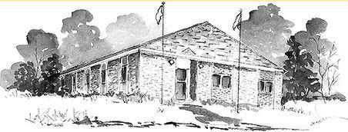 | Library Trustees  Ben Ebert, Chair  Deb Woodward, Vice Chair  Sara Walker, Secretary  Bob Giroux, Treasurer  Margot Vanscoy, At Large

Georgia Public Library Trustee Meeting
Monday, February 26, 2024 5:00PM
Location: Georgia Public Library
MINUTES

Attendance: Ben Ebert, Deb Woodward, Sara Walker, Bob Giroux, Bridget Stone
- Call to order: 5:00
- Discussion and Approval of scope for State Dept of Libraries Capital Project Grant
  - Deb moves that the Library Director go to the Select Board with the proposed Capital Project Grant Plan’s Letter of Support for signatures by Select Board. Seconded by Bob. Motion passes unanimously.
  - Bridget circulated the Letter of Support for Trustee signatures.
- Adjourn: Bob moves to adjourn at 5:45

