Georgia Public Library  1697 Ethan Allen Highway  Georgia, Vermont 05454  (802) 524-4643  www.georgiapubliclibraryvt.org  gplvt@yahoo.com | 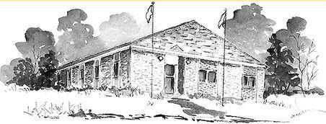 | Library Trustees  Terry Cleveland, Chair  Sara Walker, Vice Chair  Kollene Caspers, Secretary  Bob Giroux, Treasurer  Deb Mann, Trustee at Large

Georgia Public Library Trustee Meeting
Thursday, April 18, 2024 at 1:30 pm
Georgia Public Library Community Room

AGENDA

- Call to Order
- Additions, deletions, or changes to the agenda
- Approve Minutes from the 3/13/2024 Library Trustee Meeting
- Treasurer’s Report
- Review new budget with additional funds (if town budget approved)
- Library Director’s Report
- Report
- Responsibility Structure
- MSDS Report on progress- Deb
- Impact Fees and Library Reserve Fund- Bridget/Bob
- Summer Reading Program, Partnering with Fairfax Library
- Procedures regarding minutes and postings
- Executive Session, if needed
- Plan Next Meeting Agenda
- Adjourn

